Cuda Assignment: Computer Architecture

1) CUDA program that squares each element of the two vectors is implemented here are the results:

|  |  |  |
| --- | --- | --- |
| Number of elements | Cuda-c in milliseconds | C |
| 100 | 0.029728 | 2 |
| 1000 | 0.031328 | 2.5 |
| 10000 | 0.033344 | 3 |
| 100000 | 0.060384 | 6 |
| 1000000 | 0.517120 | 46 |
| 10000000 | 5.052608 | 385 |

Graph:

X axis: number of elements in the vector

Y axis time takes in milliseconds

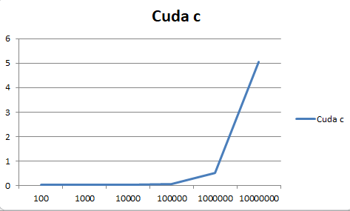

Graph cuda c vs C program:

X-axis number of elements of the vector

Y axis time taken in milliseconds

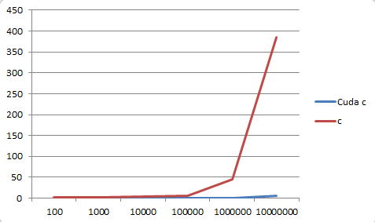

(ii)

|  |  |
| --- | --- |
| Block Size | Time in millisecond |
| 4 | 0.010000 |
| 8 | 0.009600 |
| 16 | 0.011200 |
| 32 | 0.015296 |
| 64 | 0.010144 |
| 128 | 0.009858 |
| 256 | 0.013000 |
| 512 | 0.009536 |

Block size is varied from 4 to 512 in vector squared addition and it is observed that changing block size does drastically vary performance of the cuda program. It can also be observed that whatever the block size provided (>8). Cuda tries to complete job as fast as possible

🡪**Streaming multiprocessor:**

The following properties were found:

Name of the device: GeForce GTX 980 Ti

Multiprocessors: 22

Cuda Cores/MP: 7

CUDA CORES: 22 * 7 = 154

Program files:

**Squarehw.cu**

2) estimating pi using monte carlo techniques. MPI, OpenMP and cuda comparision for 100000 trials

|  |  |  |
| --- | --- | --- |
| Cuda | OpenMp | MPI |
| 0.003474s | 0.018731s | 0.027852s |

**Performance**: The time taken for executing 100 trials is almost similar for Cuda, OpenMp and MPI. But as the number trials increases (say upto 800000) the performance or Cuda is very accurate and faster compared to MPI and OpenMP.

**Accuracy:** The accuracy of cuda program is high compared to MPI and OpenMP. I observe that randomness in generation of numbers is cuda kernel produces highly accurate results.

Program files:

Buffon.cu – not shared memory implementation

buffonNeedlesharedmemory.cu – implementation with shared memory.

Notes:

1. Graphs plotted using MS-excel
2. Used bench mark C program for sum of squares of two vector calculation. (Referring (I) in first question.)